Solution Paper Template
To give teams a running start, this outline for solution papers is provided as a potential way to organize your paper. It includes brief comments and advice for teams.
It is not required that teams use this template. It is provided only as a sample, for teams’ consideration of how you might organize your work.
This template is a Word doc for ease of use. If your team decides to use it, remember to format and save your file as a PDF before uploading as your M3 submission.

Title of Your Choice - Summary
This is also known as the “Summary” or the “Executive Summary”
This is an important part of the paper. It lets the reader know what to expect and demonstrates your ability to communicate your methodology and modeling results concisely. As quoted from the M3 Challenge guidelines:
SUMMARY of results must be the first page of your solution paper, clearly identified and not more than one page in length. It should be a concise, straightforward explanation of the main results and answer the questions posed, written with minimal use of technical language.
The summary must briefly hit all the main points and ideas of your paper as well as describe the mathematics you used. If you did anything creative, include a brief description. Do not forget, the numerical results need to be included in the summary: “Our model predicts that by the year 2034, 98% of widgets will no longer be in use”.
The summary should be written last so that you know what you are writing about and have a bigger picture of the implications of your findings. The summary (and ideally the whole paper) should be written collaboratively, as a team.
Keep in mind that the summary is the first thing your reader will encounter, so you’ll want to put your best foot forward. Make sure you allocate time to proof-read it carefully.

Table of Contents (optional)
Include a basic table of contents here. While not required, it often helps to have this page to organize the document both for the team and the judge. Note: if you are already close to 20 pages for the main body of the paper, then a table of contents is not needed.

Title of Your Choice

Introduction
Sometimes questions are open-ended and ill-defined. For example, you might be asked the “best” way to do something, but it’s not clear what is meant by “best.” In the introduction, you want to restate the problem as you interpret it. Different teams may interpret certain aspects of the challenge question differently, and the judges need to know what question your team is answering. Clearly explain your team’s notion of the problem statements. The introduction is also a place to give a little more background and motivation about the underlying real-world problem.

For each of Questions 1, 2, and 3
The purpose of a mathematical model is to predict how some real-world system will behave and to help to understand it. For each question in the challenge, there should be a section to describe the mathematical models. Most question write-ups can be broken down into three parts: the models, the solutions, and a discussion of the findings. Each of those may have subsections, depending on how you decide to organize things.
The Model
When describing the model, you need to state your assumptions, define your variables, state any parameters you are fixing to specific values, describe the mathematical relationships, processes, functions, or components that are the building blocks of your model. Make sure you explain why you made the modeling decisions you did, including how you decided which factors were most important and which ones you would leave out. You may choose to make those subsections as necessary. Throughout, be sure to cite any sources you used to find information (refer to the References section below for more guidance).
Solution(s)
For each question, there must be a description of how the model was used to answer the driving question. Did your model determine a ranking system? Did you solve an equation using software? Did you write a computer program to serve as a simulation tool? Did you evaluate a function that you created over a specific set of scenarios?
Here, you will actually present the results, so you need to decide the best way to do that. Do you need separate sections that describe how your model works for different cases? Should you use a graph or a table? Point out the general trends and any exceptions to the rules. See section 3 for guidance about including tables and graphs.

Discussion
Here you need to explain the implications of your model. What did the model reveal about the underlying problem? What conclusions can be made using the model?
Identifying strengths and weaknesses of the model is a great way to go over the key things – explain the good and bad points of your approach. Your model will be viewed more favorably if you identify weaknesses; it shows that you have considered other aspects that you didn’t necessarily have time/computational tools to consider. A few words about other possible approaches may also be useful. What would you do if you could work on this problem for the next few months? Were there any algorithms that you thought would be great, but just could not implement on the computer? Time is very limiting, so this is a place to show that you can see the big picture.
Sensitivity Analysis (Optional but encouraged when possible)
If you have the time or opportunity to thoroughly explore the parameters of your models, you should demonstrate that and explain what was learned. How dependent are the results on the parameters you used? If you change your assumptions slightly, does it have a big impact on the results? This is a chance to show you have probed all aspects of your model as best you could.
Other items for consideration
- Check that the units are consistent.
- All variables and parameters should be clearly defined.
- Fully explain any complicated mathematical expressions and include motivation for their use.
- When citing outside sources, clearly explain what statistics, models, equations, or insights you took from each source.
- If you’re including code (optional): Code may be in the main body of the paper or included as an appendix, or a combination of the two. More details on this appear in the Appendix section at the end of this template.

3. Sample Tables and Figures
Tables and figures can be very useful for displaying data in an organized fashion to the reader. Here’s some guidance on including tables and figures, followed by a sample table in a few sample figures.
- All tables should have a title, a header, a label, and a caption.
  - A sample table appears on the next page.
  - Notice it has a label (Table 1), a title (and notice that the title includes a reference citation, [8], so it’s clear where the data came from) a header (the top row that indicates what’s in the table), and a caption that indicates what the reader should take away from the table.
  - Note that units are included in the table.
  - Note that since we included a table, we should refer to it in the body of the paper. For example, “In Table 1 we can see…”
- All figures and graphs should have a title, a label, a caption, and the axes should be labelled.
  - A couple samples of figures are included.
  - Make sure the font is big enough to be readable.
  - Consider whether you can include graphs side by side to save space.

Table 1
Average daily intake of fruit and vegetables, 2007-10 [8]
Food group | Total | At home | Away from home
 |  |  | Total | Restaurant | Fast food | School | Other
Fruits (cups)
Total population¹ | 1.05 | 0.94 | 0.12 | 0.02 | 0.02 | 0.03 | 0.05
Children² | 1.08 | 0.90 | 0.18 | 0.01 | 0.02 | 0.10 | 0.05
Adults² | 1.05 | 0.95 | 0.10 | 0.02 | 0.02 | 0.00 | 0.06
Lower income³ | 1.01 | 0.89 | 0.12 | 0.02 | 0.01 | 0.04 | 0.05
Higher income³ | 1.08 | 0.96 | 0.11 | 0.02 | 0.02 | 0.02 | 0.05
Vegetables: (cups)
Total population¹ | 1.42 | 0.96 | 0.47 | 0.18 | 0.17 | 0.02 | 0.10
Children² | 0.92 | 0.59 | 0.33 | 0.07 | 0.14 | 0.07 | 0.05
Adults² | 1.59 | 1.08 | 0.51 | 0.21 | 0.18 | 0.01 | 0.11
Lower income³ | 1.26 | 0.88 | 0.38 | 0.11 | 0.16 | 0.03 | 0.08
Higher income³ | 1.53 | 1.01 | 0.52 | 0.22 | 0.17 | 0.02 | 0.11

As this table indicates, all demographic groups in the US are, on average, eating less than the daily recommended allowance of fruit and vegetables.

Figure 1
Eligibility for assistance among the food insecure in Texas in 2015 [9]

This data demonstrates that among individuals in Texas facing food insecurity, about a third are ineligible for federal nutrition assistance.

Figure 2
Heat index and visitorship data in Arcadia National Park [9]

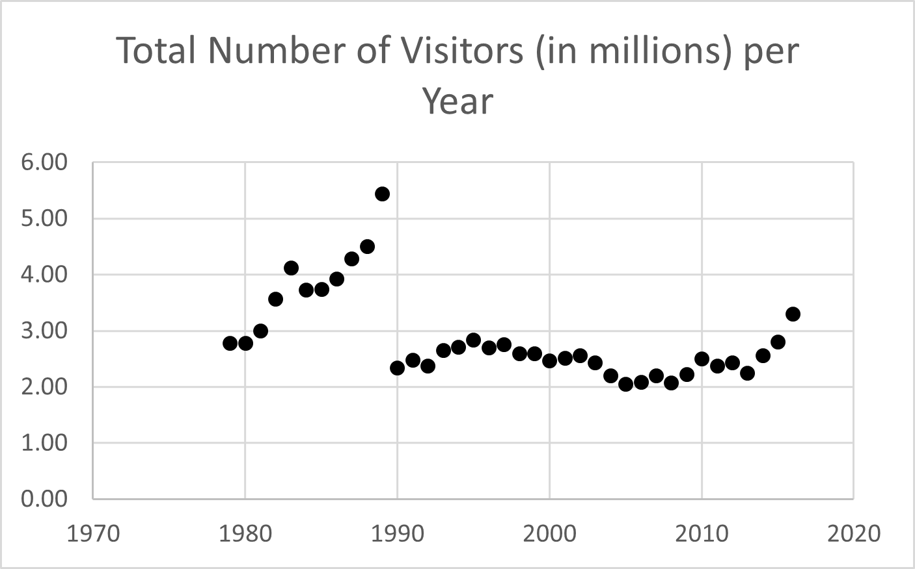
2A: The National Parks service provides this data on visitorship to Arcadia National Park. Note that the Park Service changed its counting method, leading to the apparent drastic change in 1990.

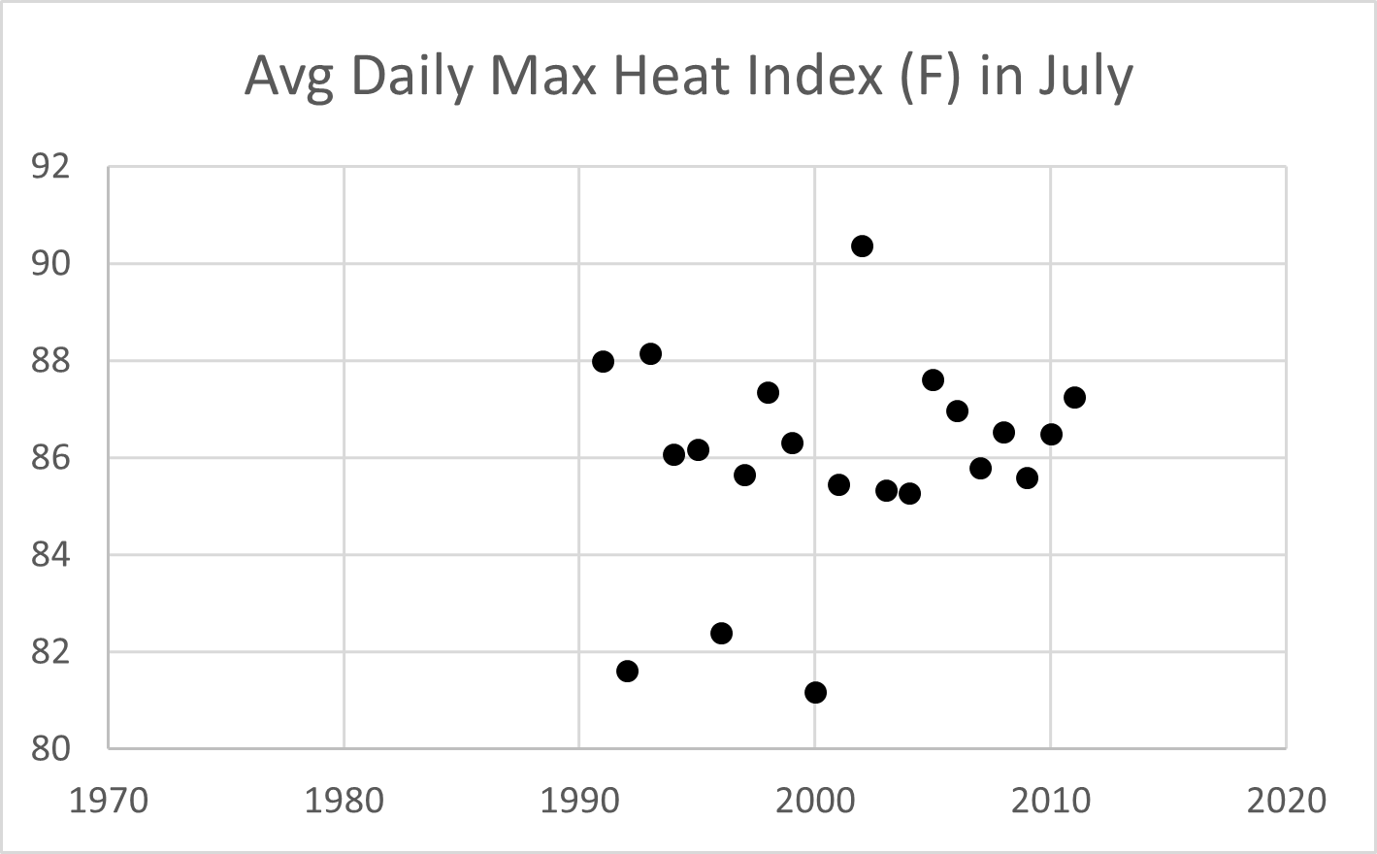
2B: It is difficult to discern a trend in the average Daily maximum heat index data.

Conclusions
Summarize the main results, even though you just presented it in detail above. What are the main take-away messages of your investigation?

References
Don’t forget to reference any resources that you use. You’re going to spend a lot of time digging through books and web pages looking for things that work. Every time you find something MAKE A NOTE! You’ll come up with some original ideas of your own of course, but most of what you’ll do is take existing ideas and adapt them.
- At the end of your paper: A list of all references used should be placed at the end of the paper in a bibliography or references page. No particular citation style is required so long as you are consistent.
- Throughout your paper: When a quote, figure, equation, statistic, paraphrased idea, insight, or any other information from a source is used/mentioned in your paper, it should be marked with an in-text citation, such as (Simmons 2002) or simply [17], referring to the full list of references at the end. This citation should indicate exactly what bibliography entry is being used, and it should be accompanied by a clear explanation or summarization of what information was used from the cited source. Any standard citation format is acceptable, just be consistent throughout the paper.
When you use someone’s idea without including a reference, that’s PLAGIARISM! Even if you’re not stealing words, but just ideas, that’s still plagiarism, so don’t do it!
Note that the Reference page(s) do not count toward the recommended 20-page limit.

Code Appendix (optional)
Writing code is not required for competing in the Challenge, but if you want to be eligible for the Technical Computing Scholarship Award (distinction for coding other than spreadsheets), you must include your code. Note: If you do write and include code for Technical Computing Award consideration, remember to check the “Technical Computing” box on the upload page when submitting your paper.
Code can be included in the body of the paper or as an appendix to your submission, or a combination of both. Appendix pages do NOT count towards the recommended 20-page limit. No matter where your actual code appears (in the body of the paper, in the appendix, or some combination of both), the code must be clearly explained (at a “big picture” level) in the main text of the report. What is the purpose of the code written and how does it help answer the challenge question?

Considerations about the discussion in the paper:
- Teams must justify the use of technical computing. That is, it must be clear why the team leveraged a computer program instead of just a calculator.
- Teams should include a brief summary of the purpose and key features of their code.
- If “built-in” functionality is used:
  - it should be clear that the team knows what the underlying function does and why it was chosen, and
  - the input parameters should be clearly provided and justified.
- For example, the following would be considered a weak explanation.
We fit an AR model in MATLAB to the time series and got the plot below.
This could be improved as follows.
Since the time series did not appear to follow a simple linear or logistic trend, we chose to fit it with an Autoregressive (AR) model. This model approximates a time series using the equation..... To fit the model to our time series, we used MATLAB's built-in "arima" function. This function can actually fit more general ARIMA models, so to fit an AR model, we set the input parameters D and q to 0. The other parameters p was chosen to equal 5 because....
- Teams should include an explanation or demonstration of how the code was tested for accuracy or correctness.

Considerations about the code itself:
- Variables should have meaningful names.
- Code should use consistent indentation for easy readability.
- Code should have comments included that describe how the code works.

